AI Customer Support Escalation & Resolution System
Zapier | Zendesk | OpenAI | Webhooks | Gmail | Slack | Airtable | Google Sheets

Project Overview
Built an automated customer support system that manages support requests from initial ticket creation through classification, routing, follow up, escalation, resolution, and customer satisfaction tracking.

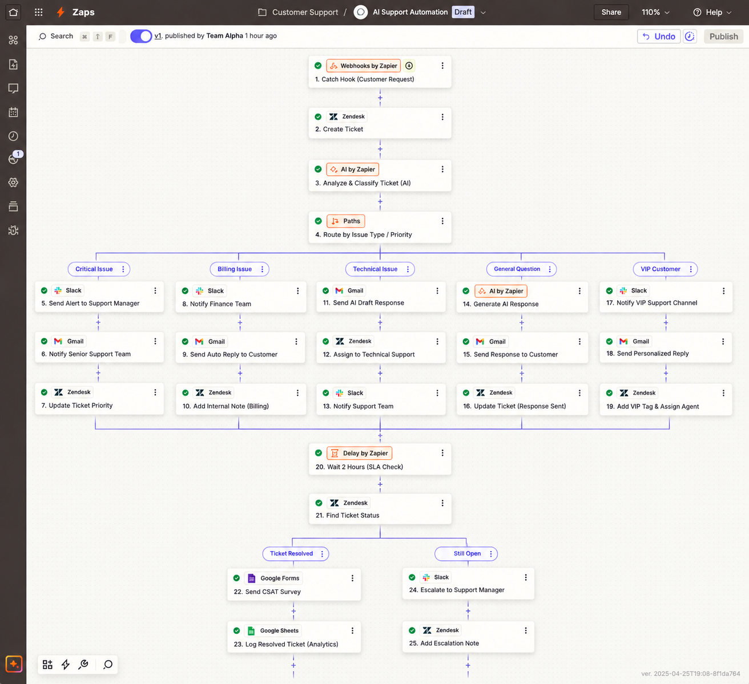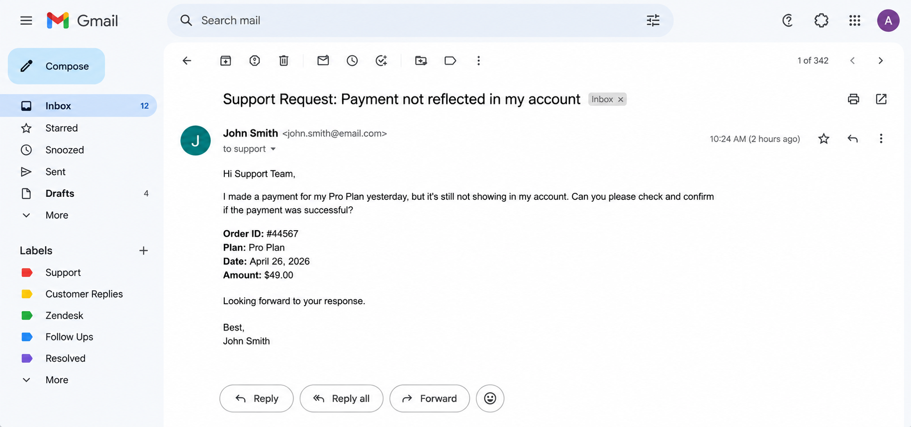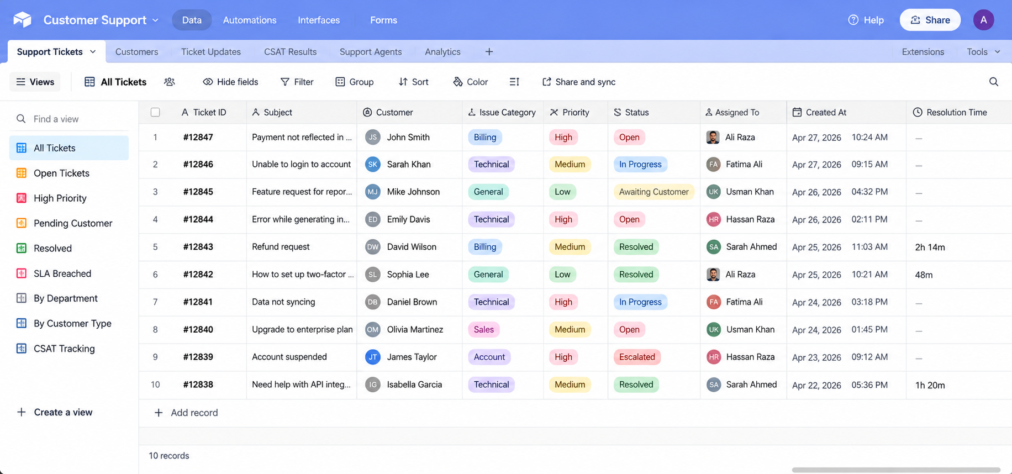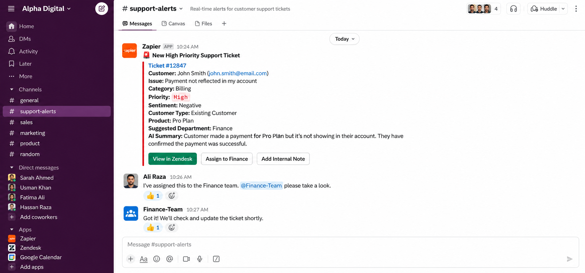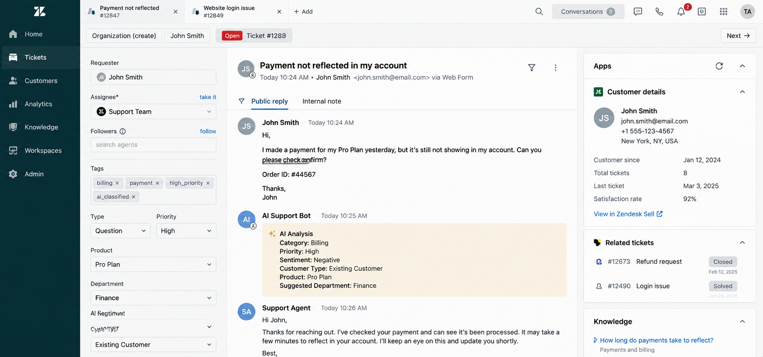

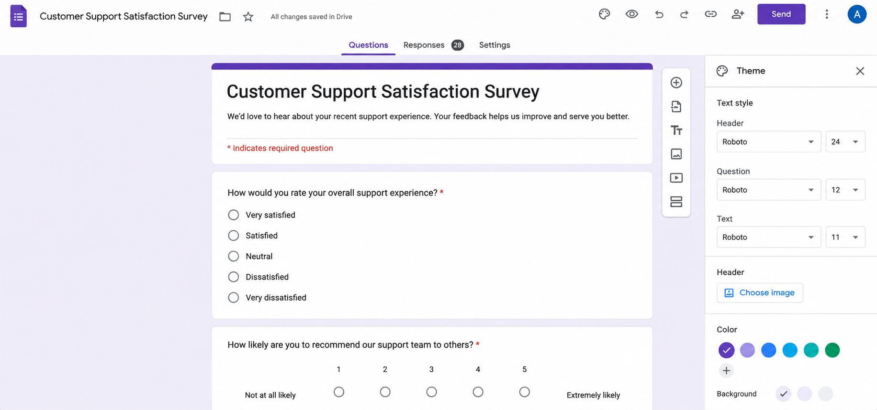

Ticket Management
The workflow:
• Receives requests through email, forms, or chat
• Creates a Zendesk ticket
• Analyzes the ticket details
• Identifies the issue category and urgency
• Determines customer type and required department
• Routes the ticket to the appropriate support workflow

Smart Routing
The system routes tickets based on their conditions:
• Critical issues → Senior Support + Slack Alert
• Billing issues → Finance Team
• Technical issues → Technical Support
• General questions → Automated Response
• VIP customers → Priority Handling

AI Ticket Analysis
Each ticket is evaluated for:
• Issue category
• Urgency
• Customer type
• Product or service
• Sentiment
• Required department

Customer Responses
For simple requests:
• Generates a response
• Sends the response to the customer
• Updates the ticket
For complex requests:
• Creates a response draft
• Sends it to a support agent for review
• Waits for the agent to handle the case

SLA Monitoring
The workflow checks whether tickets are handled within the required timeframe.
Example:
Ticket Created → Wait 2 Hours → Check Status → Resolved / Escalate
Unresolved tickets trigger an internal Slack alert and escalation.

Sentiment Escalation
If a ticket is marked as highly negative and belongs to a VIP customer:
• Escalates the ticket immediately
• Notifies the support manager
• Prioritizes the case for review

Resolution & Follow Up
When a customer responds:
• Reanalyzes the latest message
• Checks whether the issue is resolved
• Closes resolved tickets
• Escalates unresolved cases
• Sends a customer satisfaction survey

Reporting
Resolved tickets are recorded with:
• Customer
• Category
• Priority
• Resolution time
• Sentiment
• CSAT score

Technology
• Zapier
• Zendesk
• OpenAI
• Webhooks
• Gmail
• Slack
• Airtable
• Google Sheets
• Typeform / Google Forms

Result
A complete customer support workflow that connects ticket management, automated responses, smart routing, SLA monitoring, escalation, resolution, and customer satisfaction tracking into one system.

